Introduction to Multimodal AI

Goal
The primary goal of this document is to provide a clear, comprehensive, and beginner-to-intermediate friendly introduction to multimodal AI, what it is, why it matters, how it works, its real-world applications, core capabilities, processing pipeline, implementation insights, and limitations. By the end, you should be able to:
- Understand multimodal AI conceptually and distinguish it from traditional unimodal AI
- Recognize multimodal elements in everyday tools and products
- Identify opportunities to apply multimodal techniques in projects or products
- Grasp the typical workflow and common challenges when building or using multimodal systems
Multimodal AI means one system that can understand or work with more than one kind of information, not just words.
Humans are naturally multimodal.
When you hear “I’m fine,” you don’t rely only on the sentence. You also notice the tone, the face, the pause, the vibe. That mix is what makes the meaning real.
AI becomes “multimodal” when it can do something similar: combine different input types to understand better, search better, explain better, or act better.

Imagine this: You're chatting with a friend who says, "I'm fine." But their voice cracks, their face looks downcast, and there's an awkward pause. Do you take those words at face value? Nope! You blend the tone, expression, and vibe to get the real story. That's multimodal thinking in action, using multiple "senses" to understand the world.
Multimodal AI does the same. It's a system that handles more than one type of information at once – not just text, but images, audio, video, and beyond. Why? Because the world isn't flat text; it's a rich mix of sights, sounds, and structures. When AI combines these, it understands better, searches smarter, explains clearer, and even acts more effectively.
Think of it as upgrading from a black-and-white TV to full-color 4K with surround sound. Suddenly, everything pops!

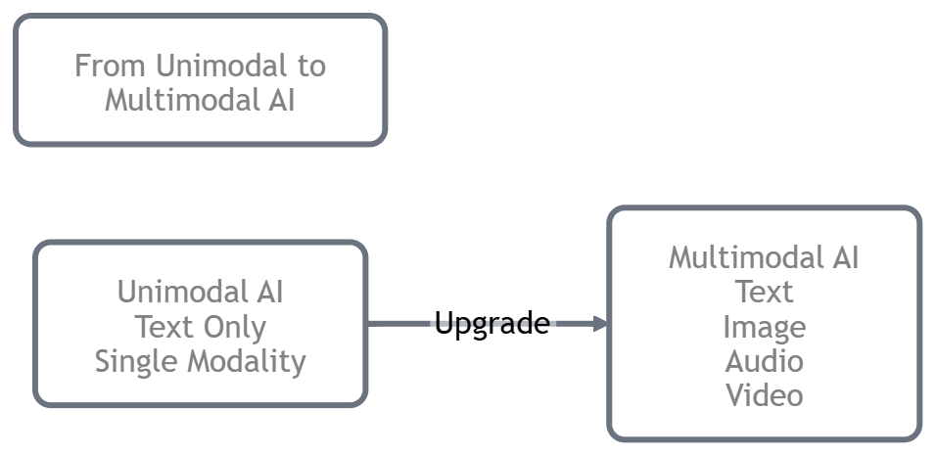

What is a Modality?
A "modality" is just a fancy word for a way information comes to us – like different channels on your senses. Machines need to "get" these to mimic human smarts. Let's explore the main ones, with examples that'll make you nod and say, "Oh yeah, that's everywhere!"

Text Modality
- Text: The simplest for AI because it's already words and symbols. But don't underestimate it, it's packed with meaning!
  - A breaking news headline that grabs your attention.
  - Your latest WhatsApp banter with friends.
  - An Amazon product blurb that convinces you to buy.
  - A Yelp review that saves you from a bad dinner.
- Real-World Example: Sentiment analysis in customer reviews, where AI processes text to gauge satisfaction levels for brands like Netflix.

Image Modality
- Images: These convey stories through visuals – shapes, colors, vibes. AI has to "see" the details.
  - A sunny selfie with that perfect beach glow.
  - An X-ray scan spotting a hidden issue.
  - A close-up of a gadget showing its sleek design.
  - A meme screenshot that cracks you up instantly.
- Real-World Example: In autonomous vehicles, like Tesla's Autopilot, AI processes camera images to detect road signs, pedestrians, and obstacles in real-time.

Audio Modality
- Audio: Sound waves carrying emotion, info, and atmosphere. Tone often trumps words!
  - A podcast episode that motivates your morning run.
  - A heated customer service call where frustration boils over.
  - A catchy song snippet that hits you with nostalgia.
  - A noisy lecture recording from a bustling classroom.
- Real-World Example: Voice assistants like Amazon Alexa use audio to recognize commands and detect emotions, enabling features like adjusting music based on your tone.

Video Modality
- Video: Images in motion, plus time and often sound. It's about what happens, not just what is.
  - Security footage catching a sneaky moment.
  - A step-by-step cooking tutorial that makes you hungry.
  - A highlight reel of a game's epic comeback.
  - A viral travel video capturing adventure vibes.
- Real-World Example: In social media platforms like TikTok, AI analyzes videos to recommend content by combining visual actions, audio tracks, and text overlays.

Document Modality (e.g., PDFs, Slides, or Scans)
- Documents (like PDFs, slides, or scans): These blend text with layout – they're visual puzzles.
  - A legal contract with bold clauses and tiny footnotes.
  - Your resume formatted to impress recruiters.
  - A scientific paper mixing graphs and equations.
  - A scanned receipt that's more picture than searchable text.
- Real-World Example: In legal tech, tools like Adobe Acrobat use multimodal AI to extract clauses from scanned contracts, combining OCR (optical character recognition) with layout analysis.

Table Modality
- Tables: Organized data in rows and columns – logic in a grid.
  - Your monthly budget spreadsheet tracking expenses.
  - A sales report comparing quarterly wins.
  - A gadget spec chart helping you choose.
  - A menu table with prices and allergen notes.
- Real-World Example: Financial apps like Mint analyze table data from bank statements to categorize expenses and provide budgeting insights.

UI Screen Modality (Apps, Websites, Dashboards)
- UI Screens (apps, websites, dashboards): Interactive layouts with buttons, alerts, and flow.
  - A confusing app screen yelling "Error – try again!"
  - A fitness tracker dashboard flashing your daily steps.
  - An e-commerce checkout with a glaring promo code field.
  - A banking app highlighting suspicious transactions in red.
Real-World Example: Accessibility tools in apps like Google Chrome use UI screen analysis to describe elements for visually impaired users, combining text labels with visual positions.

Multimodal isn't about piling on files. It's about how information whispers (or shouts) meaning through different forms. Master this, and you'll spot multimodal magic in your daily life.
Now that we've got the ingredients (modalities), let's cook! Multimodal AI shines in five core "jobs." We'll break them down with examples that feel real and relatable – think of these as superpowers your AI can unlock.
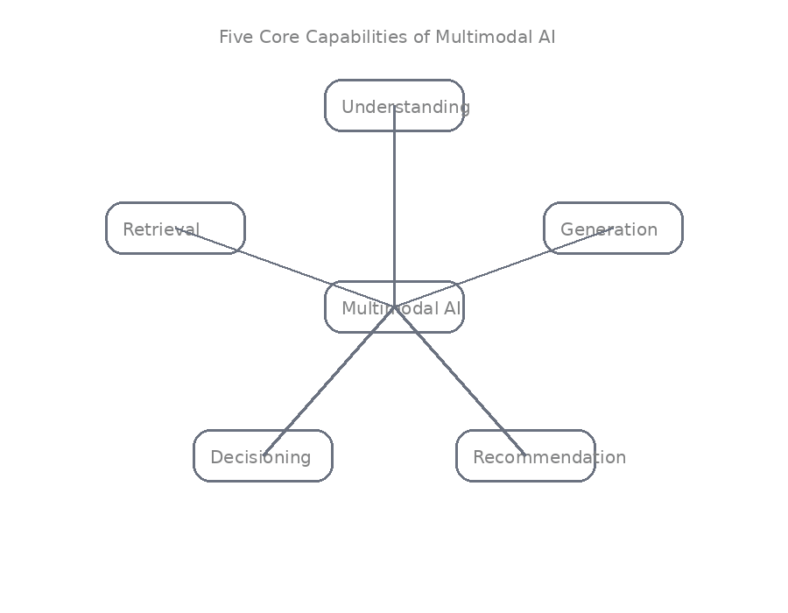
Understanding
AI "reads" the room by blending modalities to grasp the full picture.
- Visual Question Answering (VQA): Show a photo and quiz it – "What's the weather like here?" or "Count the cars in traffic."
- Document QA: Upload an invoice PDF and ask, "What's the subtotal?" or "When's payment due?"
- Audio + Text Combo: Analyze a call transcript plus tone – "Did the client sound excited or skeptical?"
Real-World Example: In education, tools like Google Lens allow students to point their camera at a math problem (image) and get explanations (text), combining visual and textual understanding.
Code Implementation Example: Here's a simple Python code using libraries like torch to simulate basic VQA (conceptual; in practice, you'd use pre-trained models like CLIP).
import torch
from PIL import Image
import clip # Assuming CLIP is available or simulated

# Load pre-trained CLIP model (text-image alignment)
model, preprocess = clip.load("ViT-B/32")

# Example image and questions
image = preprocess(Image.open("example_photo.jpg")).unsqueeze(0) # Pretend image input
questions = ["What's the weather like here?", "Count the cars in traffic."]

# Tokenize questions
text_tokens = clip.tokenize(questions)

# Get embeddings
with torch.no_grad():
image_features = model.encode_image(image)
text_features = model.encode_text(text_tokens)

# Compute similarities
logits_per_image = image_features @ text_features.T
probs = logits_per_image.softmax(dim=-1)

# Output most likely answer (simplified)
print("Most relevant question:", questions[probs.argmax()])

Retrieval:
Smart search that goes beyond keywords – it matches meanings.
- Image to Text: Upload a shoe pic and find "Matching styles in our store."
- Text to Image: Describe "Cozy cabin in the woods" and pull up perfect visuals.
- Document Snippets: Query a 100-page report for "Vacation policy details" – get just the right paragraph.
Real-World Example: Pinterest's visual search lets users upload images to find similar products, retrieving text descriptions and links.
Code Implementation Example: Simple retrieval using vector similarity (e.g., with numpy for embeddings).
import numpy as np

# Simulated embeddings (text and image as vectors)
text_embedding = np.array([0.1, 0.2, 0.3]) # For "Cozy cabin in the woods"
image_embeddings = {
"image1": np.array([0.1, 0.25, 0.35]),
"image2": np.array([0.5, 0.6, 0.7])
}

# Compute cosine similarity
def cosine_sim(a, b):
return np.dot(a, b) / (np.linalg.norm(a) * np.linalg.norm(b))

# Find best match
best_match = max(image_embeddings, key=lambda k: cosine_sim(text_embedding, image_embeddings[k]))
print("Best matching image:", best_match)

Generation

AI as a cross-format artist – translating ideas seamlessly.
- Image Captioning: Turn a vacation snap into "Sun-kissed cliffs overlooking turquoise waves."
- Video Summarization: Boil a long webinar down to "Key points: 1. Intro (0:00), 2. Demo (3:45)..."
- Text to Image: Type "Futuristic city skyline at dusk" and watch it come to life.
Real-World Example: Tools like DALL-E generate images from text descriptions, used in marketing to create custom visuals for campaigns.
Code Implementation Example: Conceptual text-to-image generation stub (in practice, use diffusion models via torch).
import torch
from diffusers import StableDiffusionPipeline # Assuming available
# Load model
pipe = StableDiffusionPipeline.from_pretrained("CompVis/stable-diffusion-v1-4")
pipe = pipe.to("cpu") # Or GPU if available

# Generate image
prompt = "Futuristic city skyline at dusk"
image = pipe(prompt).images[0]
image.save("generated_image.png")
print("Image generated and saved.")

Decisioning

It thinks, then acts – like a virtual assistant with brains.

UI Helper: Screenshot a glitchy app; it says, "Click Settings > Reset Password."
- Travel Planner: Mix maps, reviews, and photos to pick "This spot's vibe matches your adventurous style."
- Monitoring Pro: Scan graphs, alerts, and data to decide "Alert: Shut down machine now!"
Real-World Example: In manufacturing, AI systems like those from Siemens monitor video feeds and sensor data to decide on machine shutdowns for safety.
Code Implementation Example: Simple decision based on multimodal inputs (text + image scores).
# Simulated scores
image_alert_score = 0.8 # From image analysis
text_alert = "High temperature detected"

# Decision logic
if image_alert_score > 0.7 and "High" in text_alert:
decision = "Alert: Shut down machine now!"
else:
decision = "All clear."

print(decision)

Recommendation

Using all signals to suggest what you want, not just generics.
- Fashion Advisor: Blend outfit images, reviews, and your past buys for "This dress fits your edgy look."
- Music Curator: Mix beats, lyrics, and your mood for the perfect playlist.
- Travel Suggester: Combine photos, ratings, and stats for "Hidden gems safe for solo trips."
Real-World Example: Netflix recommends shows by combining viewing history (text logs), thumbnails (images), and trailers (video/audio).
Code Implementation Example: Basic recommendation using combined scores.
import numpy as np

# Simulated modalities: image score, text review score, audio mood score
item_scores = {
"Item1": {"image": 0.9, "text": 0.8, "audio": 0.7},
"Item2": {"image": 0.6, "text": 0.9, "audio": 0.5}
}

# Weighted average
def combined_score(item):
return np.mean(list(item_scores[item].values()))

# Recommend highest
best_item = max(item_scores, key=combined_score)
print("Recommended:", best_item)

The Multimodal AI Process
Most multimodal magic follows this 5-step dance. It's like a recipe you'll remix throughout the course. Get this down, and everything clicks.
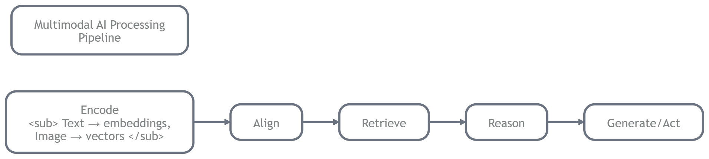
Encode: Turn raw inputs into AI-digestible "vectors" (fancy numbers representing meaning).
- Text → Word embeddings.
- Image → Pixel patterns as vectors.
Align: Sync modalities so "apple" text matches apple images in the AI's "brain."
Retrieve: Pull relevant bits – like finding matching puzzle pieces.
Reason: Think it through – cross-check, logic it out.
Generate/Act: Output the goods – an answer, image, or decision.

Example:
You snap a menu photo and ask, "Veggie options under $10?"
- Encode: Extract text and visuals.
- Align: Link words like "salad" to green icons.
- Retrieve: Zoom in on prices and dishes.
- Reason: Filter for vegetarian + budget.
- Generate: "Try the Greek Salad ($8) or Veggie Stir-Fry ($9)."
Real-World Example: In e-commerce like Amazon, this process retrieves and recommends products by encoding search text, aligning with image catalogs, and generating personalized suggestions.
Code Implementation Example: Simplified 5-step simulation in Python.
Python
import numpy as np

# Step 1: Encode
text_vector = np.array([1, 0, 0]) # "Veggie"
image_vector = np.array([0.9, 0.1, 0]) # Menu photo

# Step 2: Align (normalize)
text_vector /= np.linalg.norm(text_vector)
image_vector /= np.linalg.norm(image_vector)

# Step 3: Retrieve (similarity check)
similarity = np.dot(text_vector, image_vector)
retrieved = "Relevant menu items" if similarity > 0.8 else "No match"

# Step 4: Reason
if retrieved == "Relevant menu items":
options = ["Greek Salad ($8)", "Veggie Stir-Fry ($9)"] # Filtered

# Step 5: Generate/Act
print("Veggie options under $10:", options)

Challenges in Multimodal AI

Multimodal AI isn't perfect – it messes up in human-like ways. Knowing these helps you build better systems. We'll spotlight three biggies, with fixes implied.
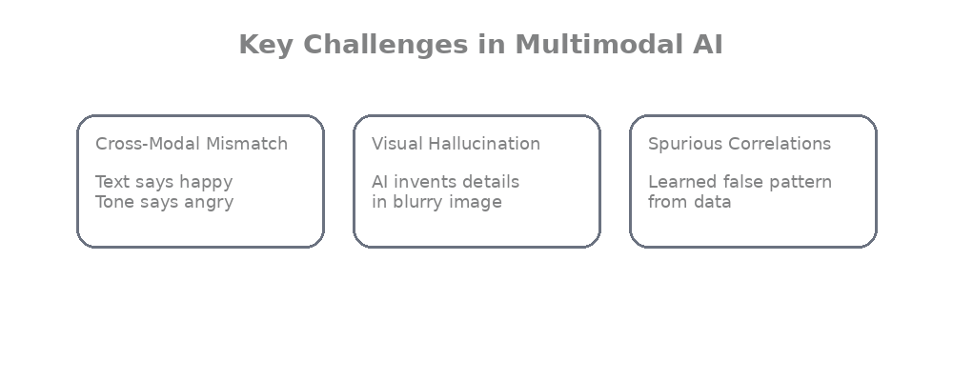
- Cross-Modal Mismatch: When signals clash (text says "happy," tone says "mad"). Why? AI might trust the wrong one. Example: A "red car" listing with a blue photo – weak AI sticks to text.
- Visual Hallucination: AI "sees" ghosts – inventing details. Why? It guesses to fill blanks. Example: Blurry label read as "Coke" when it's "Cola."
- Spurious Correlations: Lazy shortcuts from data biases. Why? Patterns aren't causes. Example: AI links "beach" to "expensive" because fancy resorts post better pics.
Real-World Example: In facial recognition systems like those used by law enforcement, cross-modal mismatches can lead to false identifications when combining images with text descriptions.
Code Implementation Example: Detecting mismatch in simple vectors.
import numpy as np

# Vectors for text ("happy") and audio tone ("mad")
text_vector = np.array([1, 0]) # Positive
audio_vector = np.array([0, 1]) # Negative

# Check mismatch
dot_product = np.dot(text_vector, audio_vector)
if dot_product < 0.5:
print("Mismatch detected: Signals clash.")

Conclusion & Key Takeaways
Multimodal AI represents the next major evolution beyond text-only language models. By integrating vision, sound, layout, motion, and more, these systems move much closer to human-like perception and reasoning.

Key Takeaways
- Multimodal = multiple input/output types fused intelligently
- Humans have been multimodal for millions of years, AI is finally catching up
- Core superpowers: Understanding, Retrieval, Generation, Decisioning, Recommendation
- Typical pipeline: Encode → Align → Retrieve → Reason → Generate/Act
- Real products already use it: assistants, search, content creation, healthcare, autonomous systems
- Challenges remain: hallucinations, mismatches, cost, ethics,but progress is rapid
Whether you're building products, conducting research, or simply want to understand the AI tools shaping our world in 2026 and beyond, multimodal capabilities are becoming table stakes. The future isn't just language, it's sight, sound, motion, and meaning working together.

